WIFI Intelligent Valve Manipulator Operation Instructions

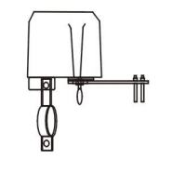

Thank you for using our intelligent valve manipulator. Please read this manual carefully before using it.

I. Product Profile

Welcome to choose our company's WIFI intelligent valve manipulator products. This product has the characteristics of intelligence, long distance, low cost and high reliability. It adopts WIFI international technology and is fully compatible with WIFI network. It can control the valve switch by wireless, remote and timing. It is an ideal product for intelligent home safety and automatic control of agriculture and forestry irrigation.

II. Product Specifications

Power supply voltage: 12V/1A

Communication technology: WIFI

Communication frequency: 2.4G

Wireless Distance (Outdoor): 30m

Valve pressure: 1.6 Mpa

Valve specifications: 4, 6, 1 inch, 1.25 inch

Automatic shutdown time: 5-10 seconds

Automatic valve opening time: 5-10 seconds

Torque: 30-60 kg.cm

Application: IOS/android

Application Valve Type: Handle Valve Switch

III. Installation Guide

1. Valve controller installation must be on the same axis between valve controller axis and valve center axis, otherwise the valve can not be completely closed and opened.

2. After the valve controller is installed, the clutch pull ring can be pulled down manually, and the controller handle can be switched manually to check whether the valve switch is in place.

3. Connect DC12V/1A power adapter.

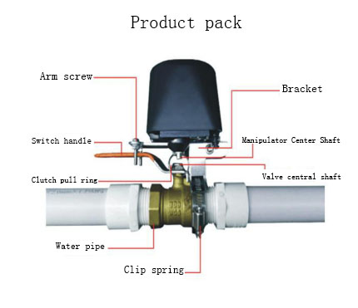

IV. Guidelines for Use

1. Scan two-dimensional code, download "smart Life" APP, install and open APP, prompt the registration account according to its instructions.

2. Add equipment: click add +, select other equipment, press the button for about 5 seconds, then the indicator flashes quickly, the intelligent valve enters the distribution network state, according to the prompt input WIFI password and other operations, until the match is successful.

3. The default state of the smart valve after matching is shut-off state. The switch of the valve can be operated according to the need. When the smart valve is opened, the indicator lights are always on. When the valve is closed, the indicator lights are not on. You can manually press the switch valve, or you can use the mobile phone APP to operate the switch valve. The product has setting functions such as timing, sharing and linkage. Please read the description of APP in detail.

4. After matching the successful intelligent valve, if the button is pressed again, the LED lamp of the intelligent valve will flash quickly, the original matching information will be eliminated, and the matching process will be carried out again. If multiple mobile devices are required to control the switch of smart valves, the sharing function of APP is adopted and allocated to multiple accounts.

5. In the absence of wifi, the smart valve can control the switch of the smart valve. When the state of the smart valve is off, it opens after the key, and vice versa. When the power is cut off, the pull ring under the intelligent valve can be manually pulled down to rotate the handle and switch the valve.

V. Failure Guidelines

1. The valve controller switch is not in place: Check whether the valve controller axis center and the valve center axis are in the same axis, if not in the same axis, not only make the intelligent valve switch not in place, but also burn the motor.

2. The valve switch is stuck: you can pull down the clutch and turn the valve on with a 90 degree manual handle until the valve can be switched on and off smoothly. If the valve is too tight, it is recommended to replace the valve.

3. Valves if not paired into the network: check WIFI signals, and intelligent valves in paired into the network as close as possible to the router.

4. For other troubleshooting problems, please read APP's Help Center in detail.

Notes

1. Install the bracket on the installation ear of the manipulator (screw is not tightened first);

2. Fix the mounting bracket on the water pipe or gas pipe (as shown in the figure);

3. Adjust the position of the manipulator so that the output axis of the intelligent valve manipulator is in line with the axis of the "pipe/gas pipe" valve handle. (Fig. 1) Then tighten the screw at both ends of the mounting bracket.

4. Tighten the screw of the manipulator handle clip according to the diagram.

VII. Packaging List

1. Host 1. Instructions 1. Adapter 1. Tube clamp 1.

Disclaimer: If the product has function upgrade, you can contact our company for information without notice. The right of interpretation belongs to our company.

